Minooka Cross-Country 2019 SPC XC Championships
***BUS LEAVES after 3rd Hour (you are dismissed after 3rd)***
Meet/Date | 2019 Southwest Prairie Conference XC Championships  Friday, October 18, 2019  Host: Minooka Community High School
Place | Channahon Community Park • Channahon Park District • Google Map  23304 W McClintock Rd • Channahon, IL
Schedule | Coaches Meeting (Finish Line) 11:30 AM  Fresh/Soph Girls (3 miles) 12:00 PM Limit 7  Fresh/Soph Boys (3 miles) 12:30 PM Limit 7  Varsity Girls (3 miles) 1:00 PM Limit 7  Varsity Boys (3 miles) 1:30 PM Limit 7  Open Girls (3 miles) 2:00 PM Unlimited Entries  Open Boys (3 miles) 2:30 PM Unlimited Entries  Awards Ceremony 3:10 PM
Teams | Joliet Central (Box 2), Joliet West (Box 12), Minooka (Box 7), Oswego (Box 5), Oswego East (Box 9), Plainfield Central (Box 3), Plainfield East (Box 6), Plainfield North (Box 4), Plainfield South (Box 10), Romeoville (Box 11), West Aurora (Box 1), Yorkville (Box 8)
Results | The results will also be posted on www.runminooka.com & www.raceresultsplus.com. Results will also be e-mailed to each coach after the meet.
All-Conference  (SPC By-Laws) | The All-Conference team will be the top 21 finishers at the Varsity Conference Meet.  If a coach has a player who, because of injury or illness has not participated in the conference tournament, may be added to the All-Conference team with a majority vote of the coaches.
Awards | The Conference Varsity Team Champion in the male and female division will receive a  championship plaque.  The top (21) varsity male and female runners will receive a medal for their place. The medal will designate them as All-Conference. No certificates will be issued.  The top (21) fresh/soph female and male and the top (21) open race female and male will receive a ribbon. A travelling team trophy will be presented to the F/S Team Champion.
T-Shirts | Long Sleeve T-Shirts will be available at a cost of $20.00 per shirt. Cash or Check payable to MCHS.  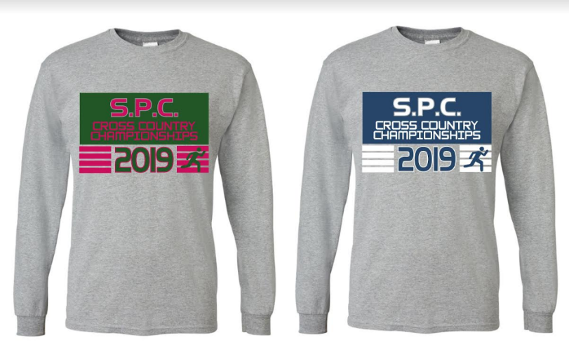

PCHS Entries:
Fr/So:
Wyckoff, DeAvila, Forbear, Mulyk, Rojo, Kacena, Torri

Varsity:
Emrath, Bonomo, Adelmann, Hale, Eubanks, Graefen, Schick

Open:
Obman, Bradley, Edmondson, Matson, Matula, Kodura, Kawa, Ruane, Ensworth, Herrera, Irizarry Jus, Koukou, Porn, Konow, Rodriguez, Fannin, Irizarry Jos, Weyer, Almawi, Garcia

Course Map:
