

HOSTED BY
PLAINFIELD CENTRAL

THURSDAY, APRIL 26TH

Welcome to Plainfield Central High School, home of the 2018 Stephen P. Hunt Memorial Track and Field Invitational. This meet is dedicated to the life of Steve Hunt, a science teacher and track and field coach at Plainfield High School, who lost his life when the school was destroyed in the 1990 Plainfield Tornado. Coach Hunt’s passion for teaching, coaching, and the community of Plainfield lives on through this meet, and tonight, we will be running, jumping, and throwing in honor of him.

Never forget the lives that were lost on August 28th 1990.

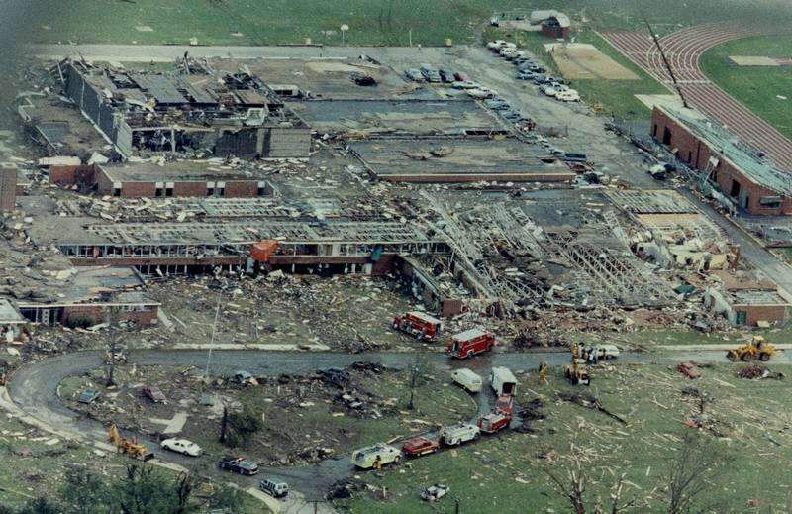

2018 Stephen P. Hunt Memorial Invitational
Hosted by Plainfield Central High School

Meet Date- Thursday, April 26th 2018

Starting Times- Field Events: 4:30 PM Running Events: 5:00 PM

Location- Plainfield Central High School Wildcat Stadium.

Schools (Boys and Girls)- Central, South, North, East.

Entries- Each school is allowed FOUR entries for individual track events, and TWO relay teams per relay track events. Entries due on Athletic.net by Wednesday April 25th by noon.

Scoring- Individual track and field events will be scored 6-4-3-2-1, while relay events will be scored 6-4-2. No limitations will be placed on how many points a team can score in each event (ex. If four athletes place, four athletes score).

Awards- Top three individual in each event will receive medals. Team champion plaques will be awarded to the top Girls and Boys teams. A traveling trophy will be awarded to the school with the highest combined Girls and Boys team score. The traveling trophy is constructed with a brick from the original Plainfield High School.

T-Shirts/Concessions- Hunt Memorial Invite t-shirts will be available for purchase for $12.00. Previous year’s t-shirts (2017 and 2016) will be available for $5.00, with limited sizes available. Concessions will be available for purchase as well.

Special Olympics- The Hunt Invite will once again be hosting a competition for the Special Olympics. These events will begin at 4:00 PM. We encourage you to talk with your student-athletes about the significance of this competition, and would love to see as many kids as we can out supporting and cheering on these extraordinary competitors.






Order of Events- The meet will be contested on a rolling time schedule. Field event athletes will check in at their respective locations. Please see our facility map on the next page.

Field Events (4:30 PM Start Time).
- Shot Put
  - Girls first, Boys second. 4 throws, no finals.
- Discus
  - Boys first, Girls second. 4 throws, no finals.

- High Jump
  - Girls first, Boys second. Starting height TBD.
- Pole Vault
  - Boys first, Girls second. Starting height TBD.
- Long Jump/Triple Jump
  - Girls and Boys at the same time. 4 jumps, no finals.

Running Events (5:00 PM Start Time). Girls first, Boys second.

- Open-Unscored 1600 Heats ***(4:30 start time)*** (Google Doc Sign up for This)

5:00 PM

- 4x800 Meter Relay (Black Exchange Zone)
- 4x100 Meter Relay (Yellow Exchange Zone)
- 3200 Meter Run
- 100 Meter High Hurdles (Girls- Yellow marks)
- 110 Meter High Hurdles (Boys- Blue marks)
- 100 Meter Dash
- MIDDLE SCHOOL COMPETITION
  - 100 Meter Dash
  - 800 Meter Run
- 800 Meter Run
- 4x200 Meter Relay (Red Exchange Zone for 1st and 2nd, Yellow for 3rd)
- 400 Meter Dash
- SENIOR NIGHT HONOREES (10-15 MINUTES)
- 300 Meter Hurdles (low for girls, intermediate for boys, Red marks)
- 1600 Meter Run (GAUNTLET- Both Girls and Boys)
  - Fans are invited onto the track to cheer for the runners!
- 200 Meter Dash
- Little Caesar’s 4x100 Meter Throwers Relay (Girls in lanes 1-4, Boys in 5-8)
  - This event will not count towards the meet score. Winners get a Pizza!
- 4x400 Meter Relay (Blue Exchange Zone for 1st, Black for 2nd and 3rd)
Awards and Champion’s Photo will occur at the conclusion of the meet.

STEPHEN P. HUNT MEMORIAL INVITATIONAL MEET RECORDS-GIRLS

EVENTS RECORD HOLDER SCHOOL TIME/DISTANCE YEAR

100 Meter Cessily Jones Plainfield North 11.94 2010

200 Meter Elaine Hayes Romeoville 25.74 2000
Muffy Israel Romeoville 25.74 2001
Cessily Jones Plainfield North 25.74 2009
Jenna Moody Plainfield Central 25.74 2013

400 Meter Jenna Moody Plainfield Central 57.12 2013

800 Meter Krysten Sebby Yorkville 2:16.94 2009

1600 Meter Ali Fester Yorkville 5:20.54 2009

3200 Meter Juliana Stogsdill Plainfield North 11:10.01 2016

100 High Hurdles Megan Gregory Plainfield North 15.04 2007

300 Low Hurdles Lisa McQuade Yorkville 46.54 2008

Shot Put Micky Barnes Joliet West 41'06" 1978

Discus Tracy Moss Minooka 136’02 ½” 1999

High Jump Lenae Ludy Plainfield South 5'08" 2011

Long Jump Mashala Kirsky Walter Lutheran 19’05” 2013

Pole Vault Meghan Voiland Yorkville 11’09” 2003

Triple Jump Isimere Edeko Walter Lutheran 37’00’ 2013

4x100m Relay Cara Hahne Plainfield North 48.07 2010
Cessily Jones
Jazmine Frank
Jesi Hawks

4x200m Relay Romeoville 1:45.4 1983

4x400m Relay Katrina Dovarski Yorkville 4:05.8 2009
Esther Bell
Ali Hester
Krysten Sebby

4x800m Relay Cara Keifer Plainfield South 9:45.2 2009
Annie Chezem
Erin David
Erin Fitzgerald

STEPHEN P. HUNT MEMORIAL INVITATIONAL MEET RECORD- BOYS

EVENTS RECORD HOLDER SCHOOL TIME/DISTANCE YEAR

100 Meter Charles Howell Plainfield Central 10.64 2003

200 Meter K. Montgomery Plainfield Central 21.16 2015

400 Meter T. Howard Bolingbrook 48.64 1998

800 Meter John Partee Plainfield South 1:56.99 2015

1600 Meter Andrew Sandoval Plainfield North 4:25.26 2011

3200 Meter Joe Suarez Plainfield East 9:27.22 2015

110M High Hurdles Raymon Parker Romeoville 14.54 2007

300 M I Hurdles M. Wolff Plainfield South 38.55 2012

Shot Put J. Rohde Yorkville 53' 11-3/4" 1992

Discus Scott Moss Minooka 172'00" 2002

High Jump T. Marion Joliet West 6'10" 1990

Long Jump F. Burk Proviso East 22' 06 ¾” 2013

Pole Vault Jake Winder Plainfield South 16’02” 2006

Triple Jump E. Crank Bolingbrook 46' 0 ½” 1989

4x100m Relay Dondre Adams Plainfield South 41.97 2011
Jalen Bonner
Alex Flores
John Magee

4x200m Relay Issiah Dunson Plainfield Central 1:30.21 2015
Sebastian Perhon
Marcus Hayes
Kahmari Montgomery

4x400m Relay Jalen Bonner Plainfield South 3:20.80 2011
Steven Harris
Juliano Lodi
John Magee

4x800m Relay Kevin Capodice Plainfield North 8:06.64 2009
Andrew Sandoval
Andrew Karas
Austin Stone

